Installation RCU
Step 1 : Important Step it is required if you are using Oracle XE DATABASE, execute the following command
export RCU_JDBC_TRIM_BLOCKS=TRUE;

Step 2 : Now go to the RCU installation path
{your soa software folder}/RCU/rcuHome/bin

Step 2 : also execute the following commands
sudo apt-get install libXext6:i386
sudo apt-get install libXtst6:i386
sudo apt-get install libXi6:i386

Step 3 : Now execute the rcu file
sudo ./rcu

Step 4 : welcome screen Click Next

Step 5 : Select Create option and then Next

Step 6 : Fill database details
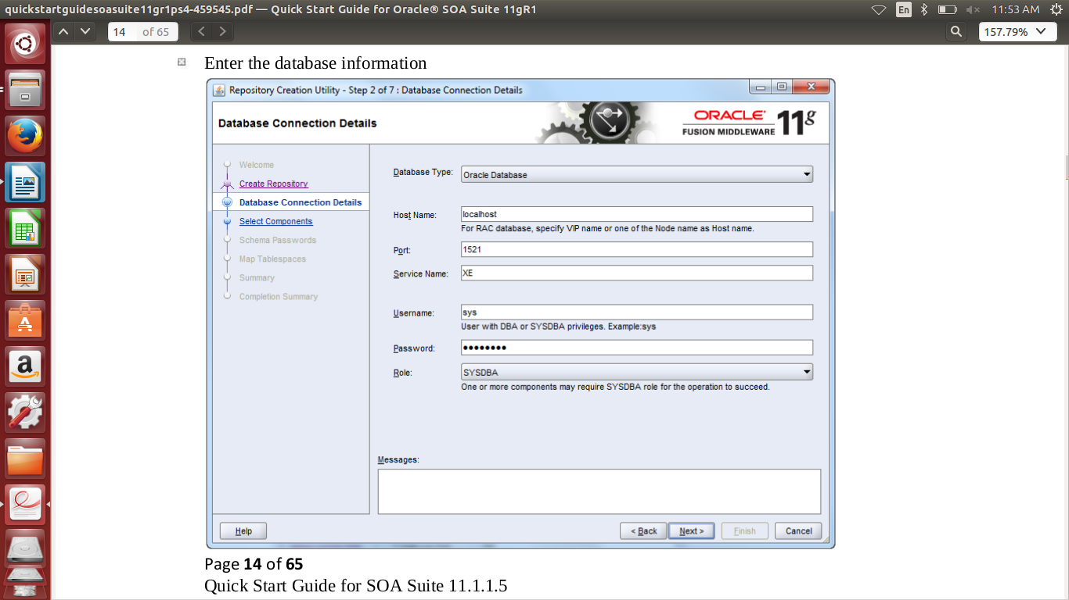
Database type : Oracle Database
Host Name : localhost
port : 1521
service name : XE
Username : sys {Or system}
password : admin123 (password of oracle database system user)
role : SYSDBA
Now Click Next

Step 7 : It will prompt some warnings please click ignore

Step 8 : Click Ok

Step 9 : Select Create a new Prefix option and its value is DEV preferable and check the checkbox as shown in screen shot below
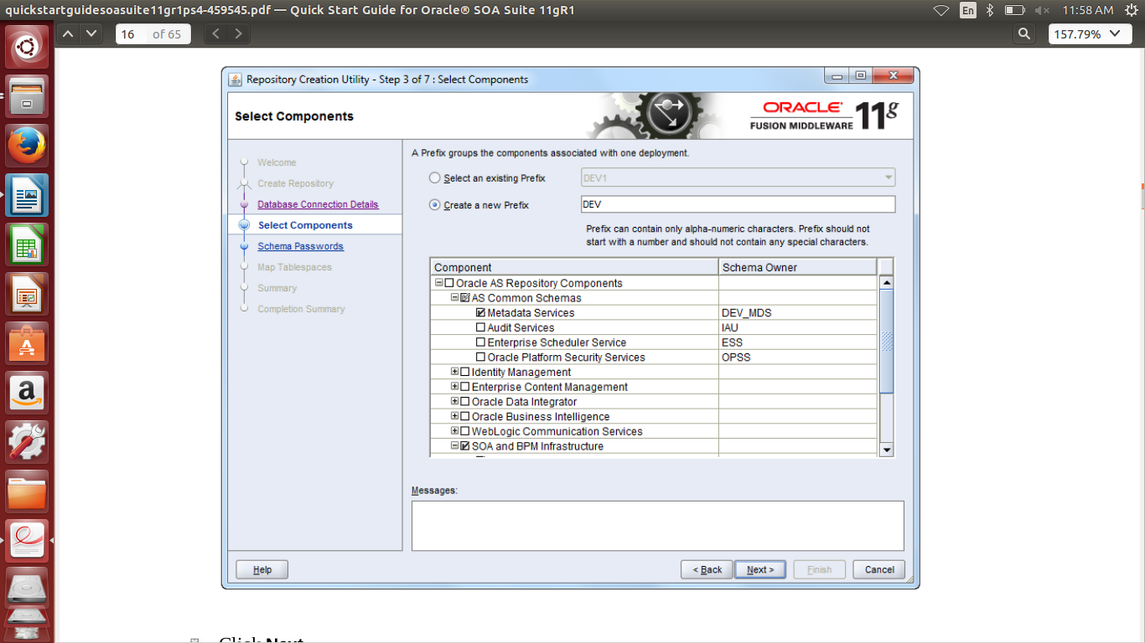
Step 10 : Click Next

Step 11 : Click Ok

Step 12 : Enter password for schema of RCU admin123 is recommended
(NOTE : please enter alphanumeric password for RCU schema and remember it because it will be used for further SOA installation so config it accurately and i suggest to keep admin123 password same as oracle database system user password).

Step 13 : Click Next

Step 14 : Now the list of Map tablespaces is listed please i suggest save it or take screen shot of it,
(NOTE : This list is important for further installation of SOA so please take a screen shot of it)

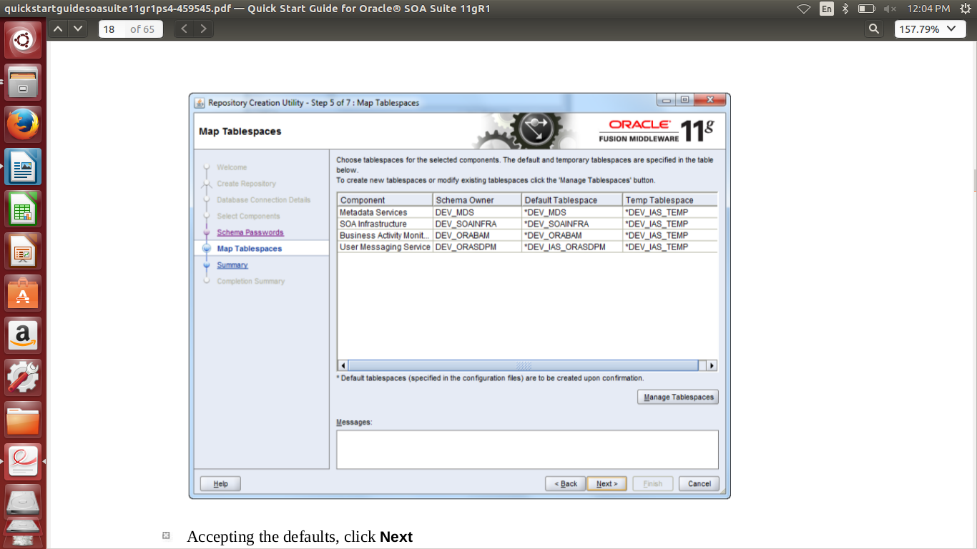
Step 15 : Click Next

Step 16 : Click Ok, then it will display total deatils of RCU config so please alot take screen shot of it

Step 17 : Click Create and wait

Step 18 : Its done Click Close

Not RCU is config so its time to install SOA Suite so move to next file

